FINAL YEAR PROJECT
CryptoSence



GOVT. GRADUATE COLLEGE, CIVIL LINES,
SHEIKHUPURA

Supervisor: Sir Muhammad Kamran

Submitted By:
Syed Mohsin Abbas | 2022-KS-178 | 2022-089330
Hamza Nadeem | 2022-KS-171 | 2022-089305

Session: 2022-2026

Project ID: 22-KS-BSIT-16
Bachelor of Science in Information Technology
FINAL YEAR PROJECT REPORT
CryptoSence

A project Presented to
Faculty of Computing and Information Technology (FCIT)
University of the Punjab
Lahore

In partial fulfillment of the requirement for the degree of
Bachelor of Science in Information Technology
Session (2022-2026)

Submitted By:
Syed Mohsin Abbas | 2022-KS-178 | 2022-089330
Hamza Nadeem | 2022-KS-171 | 2022-089305

DECLARATION
The work reported in this project was carried out by us under the supervision of our project supervisor, Sir Muhammad Kamran, at Government Graduate College, Civil Lines, Sheikhupura.
We affirm that this project, along with its contents, is the result of our independent research efforts. No portion of this work has been directly copied from any previously written or published material, except for referenced sources, standard mathematical or scientific models, equations, formulas, protocols, etc. Furthermore, we confirm that this work has not been presented for the attainment of any other academic degree or diploma.
The university may take appropriate action if the provided information is found to be inaccurate at any stage.

Student Name | Registration No. | Signature
Syed Mohsin Abbas (GL) | 2022-KS-178 | 2022-089330
Hamza Nadeem | 2022-KS-171 | 2022-089305

STATEMENT OF SUBMISSION
This is to certify that the following students have worked on their final year project, titled CryptoSence, at Government Graduate College, Civil Lines, Sheikhupura, as part of the partial requirements for the degree of Bachelor of Sciences in Information Technology.

Serial No. | Registration No. | Roll No. | Student Name
1 | 2022-KS-178 | 089330 | Syed Mohsin Abbas
2 | 2022-KS-171 | 089305 | Hamza Nadeem

Head of Department  Muhammad Ali Waqas  Associate Professor of Computer Science  Govt. Graduate College,  Civil Lines, Sheikhupura | Supervisor  Muhammad Kamran  Lecturer in Computer Science  Govt. Graduate College,  Civil Lines, Sheikhupura

Project Coordinator
Hasan Raza
Lecturer in Computer Science
Govt. Graduate College,
Civil Lines, Sheikhupura

PROOFREADING CERTIFICATE
This is to certify that Syed Mohsin Abbas (Roll#089330) and Hamza Nadeem (Roll#089305) have prepared documentation for their final year project (FYP) titled CryptoSence at the Department of Computer Science, Government Graduate College, Civil Lines, Sheikhupura, in partial fulfillment of the requirements for the degree of Bachelor of Sciences in Information Technology.

Project Supervisor
Muhammad Kamran
Lecturer in Computer Science
Govt. Graduate College,
Civil Lines, Sheikhupura

Acknowledgement
We would like to express our sincere thanks to Sir Muhammad Kamran, Lecturer at Government Graduate College, Civil Lines, Sheikhupura, for his valuable guidance, encouragement and support during the preparation of our project documentation.
We are also thankful to our friends and families for their quiet support and motivation, which helped us stay focused throughout this phase of our work.

Date: January 27, 2026

PROJECT INFORMATION

Project Title | CryptoSence
Objective | To build a Crypto Tracker with AI Chatbot
Undertaken by | Syed Mohsin Abbas and Hamza Nadeem
Supervised by | Sir Muhammad Kamran
Starting Date | 02/10/25
Completion Date | 30/06/26 (Expected)
Tools Used | Visual Studio Code
Technologies | React.JS, Node.JS, Express.JS, MongoDB, Coingecko API, Gemini API

PREFACE
This is a final year project (FYP) report written by students of Bachelor of Science in Information Technology at the University of the Punjab. We are Syed Mohsin Abbas and Hamza Nadeem, both of us are studying in BSIT (Hons) at Government Graduate College, Civil Lines, Sheikhupura.
To enable you to understand the idea of our project and the implementation process in detail and systematically, this report is divided into topics; each topic with a specific focus. We hope this approach allows you to read and understand our project report easily. Lastly, if you have any comments, you are welcome to contact us at:

Member 1: | Syed Mohsin Abbas | syedmohsinabbas7212@gmail.com
Member 2: | Hamza Nadeem | hamzanadeem4956@gmail.com

CryptoSence

Executive Summary
CryptoSence is a web based cryptocurrency dashboard which provides real time market data and basic analysis tools for users. It allows users to view live crypto prices, analyze charts, and understand market trends in a simple way. The system also includes a Cryptobot for answering user questions, a Learning Hub for educational content, a feedback system for user suggestions, and a Marketing Strategy Maker for planning marketing activities. It is developed using React.js, Node.js, Express.js, and MongoDB, and uses Coingecko and Gemini APIs for data and chatbot support. Overall, the system provides a simple and user friendly platform to help users understand cryptocurrency easily.

FYDP Overview
FYDP Title: CryptoSence
Sr. No | Roll No | Name | Signature
1 | 089330 | Syed Mohsin Abbas (GL)
2 | 089305 | Hamza Nadeem
Table 1 Project Proposal Summary
FYDP Goals
To develop an interactive crypto dashboard that combines real time price tracker with a Cryptobot, marketing strategy maker, feedback system and admin management for market understanding and analysis.
FYDP Objectives
- Provide a real time analysis of cryptocurrencies
- Provide a Cryptobot for trading support
- Display charts, trends and top cryptocurrencies
- Enable a user friendly interface for trading analysis
- Provide system for user feedback
- Help user to manage and plan activities
- Provide marketing strategy planning feature
- Provide admin management for users and feedback
FYDP Success Criteria
This project will be considered as successful if ,
- Trader is happy with the real time price update
- User can use the Cryptobot easily
- User can submit feedback successfully
- Admin can manage users and feedback
- Marketing user can create and manage strategy
Assumptions
- Users have internet access
- Basic trading knowledge.
Risks & Obstacles
- Most of the time API demand change in code
- If API key is paid then website cost is expensive
- The app may not work properly if the crypto data API becomes slow
Organization Address: Govt. Graduate College, Civil Lines, Shiekhupura
Target End Users: Retail crypto traders, students, educators, crypto communities
Suggested Project Supervisor: Muhammad Kamran
Approved by: Muhammad Kamran
Date: October 24, 2025

Table of Contents
CryptoSence 9
Executive Summary 9
FYDP Overview 10
Chapter No 1 19
Project Proposal 19
1.1. Introduction 20
1.2. Background 20
1.3. Problem Statement 20
1.4. Stakeholders & Interests 20
1.5. Objectives 21
1.6. Scope 21
1.7. Assumptions 22
1.8. Risks 22
1.9. Success Criteria 22
1.10. Tools, Libraries & Technologies 23
1.11. Work Division 23
1.12. Project Planning 24
1.13. Conclusion 24
Chapter No 2 25
Literature Review 25
2.1. Literature Survey 26
2.2. Related Work 26
2.3. Gap Analysis 26
2.4. Summary 27
Chapter No 3 28
Software Requirements Specification 28
3.1. Requirements Analysis 29
3.2. User Classes & Characteristics 29
3.3. Requirements Identifying Techniques 29
3.4. Functional Requirements 30
Functional Requirement 1 30
Functional Requirement 2 30
Functional Requirement 3 31
Functional Requirement 4 31
Functional Requirement 5 32
Functional Requirement 6 32
Functional Requirement 7 33
Functional Requirement 8 33
Functional Requirement 9 34
Functional Requirement 10 34
3.5. Non-Functional Requirements 35
1. Reliability 35
2. Usability 35
3. Performance 35
4. Security 35
3.6. External Interface Requirements 36
1. User Interface Requirements 36
2. Software Interfaces 37
3. Hardware Interfaces 37
4. Communication Interfaces 37
3.7. Use Case Analysis 37
End User Use Cases 37
Use Case #1 – Registration 37
Use Case #2 – Login 38
Use Case #3 – Forget password 39
Use Case #4 – Dashboard 39
Use Case #5 – Cryptobot 40
Use Case #6 – Learning Hub 41
Use Case #7 – Feedback System 41
Use Case #8 – Logout 42
Admin Use Cases 43
Use Case #9 – Admin Login 43
Use Case #10 – Manage Users 43
Use Case #11 – View Feedback 44
Use Case #12 – Monitor System Activity 45
Marketing User Use Cases 45
Use Case #13 – Marketing Strategy Maker 45
Use Case #14 – Referral Management 46
Use Case #15 – Growth Tracking 47
Use Case Diagrams 48
3.8. Storyboard 50
3.9. Summary 50
Chapter No 4 51
Software Design Specification 51
4.1 System Design 52
Product Perspective: 52
Dependencies: 52
Design Constraints: 52
4.2 Design Considerations 53
Assumptions 53
Dependencies 53
Limitations 53
Risks 53
4.3 Requirements Traceability Matrix 54
4.4 Design Models 55
1. Design Class Diagram 55
2. Sequence Diagram 56
3. State Diagram 58
4.5 Architectural Design 59
1. Architectural Diagram 60
2. UML Component Diagram 61
4.6 Data Design 61
1. Database Collections Structure: 62
2. Data Dictionary 63
4.7 User Interface Design 64
1. Screen Images 66
2. Screen objects and action 71
4.8 Design Decisions 71
4.9 Summary 72
Chapter No 5 73
Implementation 73
5.1. Implementation 74
5.2. Algortihms 74
5.3. External APIs/SDKs 77
5.4. Code Repository 78
Metrices of the git repository 78
5.5. Summary 78
Chapter No 6 80
Testing and Evaluation 80
6.1. Introduction 81
6.2. Unit Testing (UT) 81
6.3. Functional Testing (FT) 83
6.4. Integration Testing (IT) 85
6.5. Performance Testing (PT) 86
6.6. Summary 87
Chapter No 7 88
System Conversion 88
7.1. Introduction 89
7.2. Conversion Method 89
7.3. Deployment 89
Development Deployment 89
Production Deployment 90
Data Conversion 90
Training 91
7.4. Post Deployment Testing 92
7.5. Challenges 92
7.6. Summary 93
Chapter No 8 94
Conclusion 94
8.1. Introduction 95
8.2. Evaluation 95
8.3. Traceability Matrix 95
8.4. Conclusion 96
8.5. Future Work 97
References 98
References 99
1. World Wide Web 99

List of Tables
Table 1 Project Proposal Summary 10
Table 2 Stakeholders & Interest table 20
Table 3 Success Criteria table 22
Table 4 Tools, Libraries & Technologies table 23
Table 5 Work Division table 23
Table 6 Gap Analysis table 26
Table 7 User Classes & Characteristics table 29
Table 8 Functional Requirement 1 30
Table 9 Functional Requirement 2 30
Table 10 Functional Requirement 3 31
Table 11 Functional Requirement 4 31
Table 12 Functional Requirement 5 32
Table 13 Functional Requirement 6 32
Table 14 Functional Requirement 7 33
Table 15 Functional Requirement 8 33
Table 16 Functional Requirement 9 34
Table 17 Functional Requirement 10 34
Table 18 Use Case 1 37
Table 19 Use Case 2 38
Table 20 Use Case 3 39
Table 21 Use Case 4 39
Table 22 Use Case 5 40
Table 23 Use Case 6 41
Table 24 Use Case 7 41
Table 25 Use Case 8 42
Table 26 Use Case 9 43
Table 27 Use Case 10 43
Table 28 Use Case 11 44
Table 29 Use Case 12 45
Table 30 Use Case 13 45
Table 31 Use Case 14 46
Table 32 Use Case 15 47
Table 33 Requirement Traceability Matrix table 54
Table 34 Data Collection table 63
Table 35 Algorithm 1 74
Table 36 Algorithm 2 75
Table 37 Algorithm 3 75
Table 38 Algorithm 4 76
Table 39 Algorithm 5 77
Table 40 External APIs/SDKs 77
Table 41 UT-1 81
Table 42 UT-2 81
Table 43 UT-3 82
Table 44 UT-4 82
Table 45 UT-5 83
Table 46 FT-1 83
Table 47 FT-2 84
Table 48 FT-3 84
Table 49 FT-4 84
Table 50 FT-5 85
Table 51 IT-1 85
Table 52 IT-2 86
Table 53 PT 86
Table 54 Post Deployment Testing Table 92
Table 55 Challenges Table 93
Table 56 Evaluation Table 95
Table 57 Traceability Matrix Test 95

Table of Figures
Figure 1 Gantt Chart 24
Figure 2 End User Use Case Diagram 48
Figure 3 Admin Use Case Diagram 49
Figure 4 Marketing User Use Case Diagram 49
Figure 5 storyboard picture 50
Figure 6 Design Class Diagram 55
Figure 7 User Registration Sequence Diagram 56
Figure 8 Home page Sequence Diagram 57
Figure 9 User Registration State Diagram 58
Figure 10 Home Page State Diagram 59
Figure 11 Architectural Diagram 60
Figure 12 UML Component Diagram 61
Figure 13 Home Page design 66
Figure 14 Login Page Design 67
Figure 15 Dashboard Page Design 68
Figure 16 Cryptobot Page Design 69
Figure 17 LearningHub Page 70

Chapter No 1

Project Proposal

Introduction
This chapter explains what the CryptoSence project is and why we built it. The main idea of this project is to help users easily understand cryptocurrency data without using multiple websites. CryptoSence is a web-based system where users can see live crypto prices, check charts, use a chatbot for help, learn about crypto, give feedback, manage their activities, and also create marketing strategies. All features are available in one place, which makes it simple and easy to use.

Background
The crypto market changes very fast, and prices go up and down quickly. People who trade crypto usually use different websites to check prices, charts, and news. But many of these websites are difficult to use, especially for beginners. Users often get confused and waste time switching between different platforms. So, we created CryptoSence to solve this problem by combining everything in one system where users can easily understand and analyze crypto data.

Problem Statement
It is difficult for users to get all crypto information in one place. Most websites only show prices and charts. They do not explain things clearly. Beginners find it hard to understand the market. Users also visit many websites which takes time. There is no proper system for learning, feedback or planning. So users need one platform where everything is simple and available.

Stakeholders & Interests
Table 2 Stakeholders & Interest table
Stakeholder | Description | Interest
Crypto Traders | They want quick updates and AI help to make better trading decisions. | Real time analysis and AI support
Financial  Analysts | They want short and clear reports to study market trends easily. | Summarized crypto data
Students | They want to learn about crypto trading and how to study market data. | Learning platform and financial analysis
Admin | They manage the system and monitor users, feedback and overall performance. | System control, user management and data monitoring
Marketing Users | They use the system to create and manage marketing strategies and promote platform growth. | Strategy planning, referral management and growth tracking

Objectives
- Provide a real time analysis of cryptocurrencies
- Provide a Cryptobot for trading support
- Display charts, trends and top cryptocurrencies
- Enable a user friendly interface for trading analysis
- Provide system for user feedback
- Help user to manage and plan activities
- Provide marketing strategy planning feature

Scope
- In-scope
- The system will focus on cryptocurrency price tracking
- It will provide market updates in real time
- It will include chatbot support for analysis
- It will include learning and feedback features
- The project will be web based.
- Out-of-scope
- The system will not support live trading.
- It will not handle or store user funds.

Assumptions
This project is made with some basic assumption. It is assumed that users have internet access and know how to use a website. Users should have basic knowledge of cryptocurrency. It is also assumed that APIs like Coingecko and Gemini will continue to work properly.

Risks
There are some risks in this project. The system depends on external APIs and if these APIs stop working or become slow, the system may not work properly. Free APIs also have limits and using paid APIs may increase project cost. Security issues may also affect user data.

Success Criteria
Table 3 Success Criteria table
Success Criteria | Description
User Registration and Login | The system should allow users to register and login without errors.
Real time Crypto Data | The system should display live crypto prices correctly.
Dashboard Performance | The dashboard should load fast and show data properly.
Cryptobot Response | The Cryptobot should provide useful answers to users.
Learning Hub | The system should provide learning content for users.
Feedback System | Users should be able to submit feedback easily.
Admin Management | Admin should manage users and system data.
Marketing Strategy Maker | Marketing user should create and manage strategy properly.
Data Accuracy | The system should show correct and updated data.
Security | User data should be stored securely.
User Interface | The system should be simple and easy to use.
Error Handling | The system should show messages when errors occur.
System Stability | The system should run smoothly without issues.
Third Party Integration | APIs should work properly with the system.

Tools, Libraries & Technologies
Table 4 Tools, Libraries & Technologies table
Tools,  Libraries, And  Technologies | Tools | Version | Rationale
 | VS Code | Latest | Use to main code editor, styling
 | Libraries | Version | Rationale
 | React.JS, Node.JS, Express.JS, Chart.JS | Latest | UI design, backend, Charting
 | Technology | Version | Rationale
 | Coingecko API, Gemini API, MongoDB | Latest | Display coins information, Cryptobot, Database management

Work Division
Table 5 Work Division table
Sr. No | Roll No | Name | Role Assignment & Work Division
1. | 089330 | Syed Mohsin Abbas | Frontend & Backend
2. | 089305 | Hamza Nadeem | Frontend & Backend

Project Planning
Figure 1 Gantt Chart
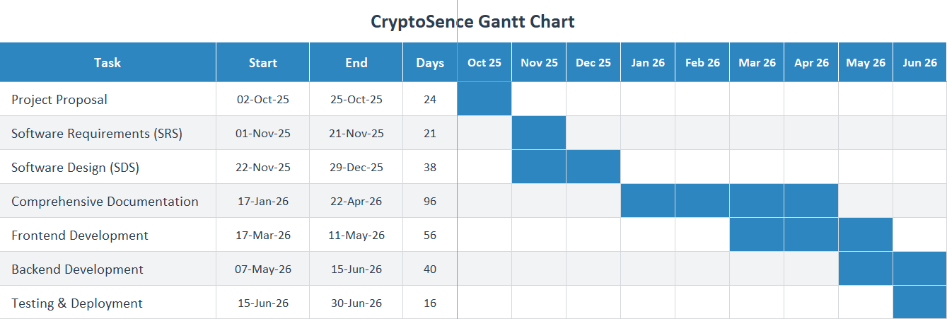

Conclusion
This chapter explained the CryptoSence project, its goals, assumptions, risks and expected results. It also showed how the system can help users understand cryptocurrency trading in a simple way and use all features in one platform.

Chapter No 2

Literature Review

Literature Survey
Many cryptocurrency platforms provide real time prices and charts. These systems help users to track market trends and monitor coins. However, most platforms only focus on data display and do not provide simple explanation, learning support or user interaction. Users also need to use multiple websites for analysis, learning and planning. This creates confusion and shows the need for a system that provides all features in one place.

Related Work
- Coinmarketcap & Binance dashboards provide real time data but lack AI interactivity.
- ChatGPT and Google Gemini can talk with users and help explain financial data in an easy way.
- TradingView offers technical analysis but no personal chat experience.
- Most systems do not include feedback or marketing planning features.

Gap Analysis
Table 6 Gap Analysis table
Existing System | Limitations | Over Solution
Current crypto dashboards mainly show charts and prices. | They only focus on visualization and do not explain the data. | Our system will provide real time crypto data with Cryptobot support.
Users can see crypto information but cannot interact or ask questions. | No option to get coin details or understand market trends easily. | The Cryptobot will answer user questions and explain crypto information.
Existing platforms are not designed for learning or easy understanding. | Users cannot learn about crypto terms or analysis through these dashboards. | The project will combine data display with AI based learning and explanations.
Most platforms do not provide feedback option. | Users cannot share their opinion or suggestions about the system. | Our system will include a feedback system to collect user responses.
Existing systems do not support marketing or planning features. | Users cannot plan activities or track system growth. | Marketing Strategy Maker will help users to plan and manage activities.
Many platforms have limited system control. | No proper management of users and system data. | Admin panel will manage users, feedback and system activity.

Summary
This chapter shows that existing systems provide data but lack explanation, learning and planning features. CryptoSence solves this by combining dashboard, Cryptobot, learning hub, feedback system, admin management and marketing strategy in one platform.

Chapter No 3

Software Requirements Specification

Requirements Analysis
The requirement analysis is a part of SRS which define what the CryptoSence do functionally and non-functionally. The main point is to create an intelligent crypto analysis platform that is secure, scalable, and easy to use.

User Classes & Characteristics
The CryptoSence have only one user class, End user.
Table 7 User Classes & Characteristics table
User Class | User Characteristics
End user | The end user can be crypto trader, student or analyst who use dashboard, Cryptobot, learning hub and feedback system.
Admin | The admin manage users, feedback and monitor system activities.
Marketing user | The marketing user create strategy, use referral system and track growth activity.

Requirements Identifying Techniques
The identifying requirements need to meeting with stakeholder by following step:
- Interview:
We conducted interviews with stakeholders which involve crypto trader, crypto teachers, financial analyst and Whatsapp crypto user groups to record user requirements.
- Ethnography and Observation:
We observed that users need a system that provides real time cryptocurrency price tracking and AI-powered support for analyzing market trends and making predictions. This system would help traders perform market analysis and make informed trading decisions without the need to visit multiple websites.
- Use Case Analysis:
Defined interactions between users and system modules (Dashboard, Cryptobot, Learning Hub, Feedback, Marketing Strategy).

Functional Requirements
This section describes the functional requirements of the system expressed in the natural language style. This section is typically organized by feature as a system feature name and specific functional requirements associated with this feature. So, for each module and it’s feature the functional requirements are itemized below:

Functional Requirement 1
Table 8 Functional Requirement 1
Identifier | FR-1
Title | User Registration
Requirement | The user shall be able to register by entering username, email and password then account create.
Source | Business Requirement
Inputs | Username, email address, and password provided by the user.
Destination | The entered user account information is stored securely in the MongoDB database.
Outputs | The system displays a successful account creation message and send to the home page.
Rationale | Provide access control and data security.
Business Rule | Password must be at least 8 characters and other also include number
Dependencies | None
Priority | High

Functional Requirement 2
Table 9 Functional Requirement 2
Identifier | FR-2
Title | User Login
Requirement | The user should be login by entering email and password then view the dashboard.
Source | Business Requirement
Inputs | Registered email address and password entered by the user.
Destination | The system verifies the credentials and creates a secure user session.
Outputs | The user is successfully authenticated and move to the home page
Rationale | Provides access control and data security.
Business Rule | User must be registered before sign in.
Dependencies | FR-1
Priority | High

Functional Requirement 3
Table 10 Functional Requirement 3
Identifier | FR-3
Title | Forget password
Requirement | The user shall be able to reset their password by email A reset link will be sent to the provided email and allowing the user to create a new password
Source | Business Requirement and interview
Inputs | Registered email address entered by the user.
Destination | The updated password is securely stored in the MongoDB database.
Outputs | A password reset confirmation message is displayed after the password is reset.
Rationale | The users regain access if they forget their password
Business Rule | The email must be registered and verified before sending the reset link
Dependencies | FR-2
Priority | High

Functional Requirement 4
Table 11 Functional Requirement 4
Identifier | FR-4
Title | Dashboard
Requirement | The user can access real time price, percentage coin and market data, search bar for searching any currencies and also view crypto currencies charts and other update which you went to know.
Source | Business Requirement and interview
Inputs | Coin name enter by the user and internet connection.
Destination | Crypto data is shown on the dashboard screen.
Outputs | Live price, percentage change, and chart of the selected cryptocurrency.
Rationale | Main functionality for traders
Business Rule | Must have good internet access
Dependencies | FR-1, FR-2, FR-3
Priority | High

Functional Requirement 5
Table 12 Functional Requirement 5
Identifier | FR-5
Title | Cryptobot
Requirement | The user can know about any cryptocurrencies prediction, trends and also few line of explanation about coins
Source | Interview, Observation
Inputs | User questions related to cryptocurrency for prediction
Destination | Cryptobot responses are generated using the Gemini API and shown on the screen.
Outputs | Simple explanations and trend information about cryptocurrencies.
Rationale | Improve the analysis of the user and market analysis
Business Rule | Need best internet support and knowledge about crypto
Dependencies | FR-1, FR-2, FR-3
Priority | High

Functional Requirement 6
Table 13 Functional Requirement 6
Identifier | FR-6
Title | Learning Hub
Requirement | The user can also access the best education platform, books and YouTube channel links which will be arranged in sequence of learning
Source | Interview, Observation
Inputs | User selection of learning content.
Destination | Learning content is displayed on the Learning Hub page.
Outputs | Educational materials, book links, and YouTube video links are shown to the user.
Rationale | Improve the skill of crypto trader and learners
Business Rule | If a student wants to learn crypto they should follow the steps in the order shown
Dependencies | FR-1, FR-3
Priority | Medium

Functional Requirement 7
Table 14 Functional Requirement 7
Identifier | FR-7
Title | Feedback System
Requirement | The user shall be able to submit feedback by entering name, email and message about the system.
Source | Business Requirement and interview
Inputs | Name, email address and feedback message provided by the user.
Destination | The feedback information is stored in the MongoDB database.
Outputs | The system displays a successful feedback submission message.
Rationale | Collect user opinion to improve system performance
Business Rule | All fields must be filled before submitting feedback.
Dependencies | FR-2
Priority | Medium

Functional Requirement 8
Table 15 Functional Requirement 8
Identifier | FR-8
Title | Admin Management
Requirement | The admin shall be able to view users, manage accounts and check feedback submitted by users.
Source | Business Requirement and observation
Inputs | Admin login credentials and system actions.
Destination | User data and feedback information is accessed from database.
Outputs | The system displays user list and feedback details to admin.
Rationale | Provide system control and monitoring functionality.
Business Rule | Only admin can access this feature.
Dependencies | FR-2
Priority | High

Functional Requirement 9
Table 16 Functional Requirement 9
Identifier | FR-9
Title | Marketing Strategy Maker
Requirement | The marketing user shall be able to create and manage marketing strategy, use referral links and track growth activity.
Source | Business Requirement and observation
Inputs | Strategy details, referral link and user activity data.
Destination | Strategy data is stored in database and used for tracking growth.
Outputs | The system displays strategy plan, referral link and activity tracking information.
Rationale | Help user to plan marketing activities and improve system growth.
Business Rule | User must be login to create and manage strategy.
Dependencies | FR-2
Priority | Medium

Functional Requirement 10
Table 17 Functional Requirement 10
Identifier | FR-10
Title | Logout
Requirement | The user shall be able to logout from the system securely.
Source | Observation
Inputs | Logout request from user.
Destination | User session is removed from system.
Outputs | The system redirects user to login page.
Rationale | Ensure security and proper session management.
Business Rule | User must be logged in before logout.
Dependencies | FR-2
Priority | Medium

Non-Functional Requirements
These are constraints on the services or functions offered by the system. They include timing constraints, constraints on the development process, and constraints imposed by standards. Non-functional requirements often apply to the system as a whole rather than individual system features or services. Following are non-functional requirements:

Reliability
- The system should be up and running 99% of the time.
- It should retry automatically if API requests fail.

Usability
- The dashboard must be easy to use and reachable in 4 clicks or less.
- The Cryptobot should use simple English.
- The design should work well on both computers and mobiles.

Performance
- Dashboard data should load within 5 seconds.
- Cryptobot replies should come within 10 seconds.
- Database tasks should take less than 200 milliseconds.

Security
- Passwords are stored safely using bcrypt hashing.
- Login uses JWT (JSON Web Tokens) for authentication.
- The site uses HTTPS for secure data transfer.
- API keys are hidden in environment files.

External Interface Requirements
This section describes how our CryptoSence system will interact with users. It covers the user interface design, software connections, and communication methods.

User Interface Requirements
- Pages:
  - Home Page with navbar and quick access buttons
  - Login / Register Page for all users
  - User Dashboard with price tracker, chart section and search bar
  - Cryptobot Page
  - Learning Hub Page
  - Feedback Page
  - Admin Dashboard Page
  - Marketing Dashboard Page
- Design Elements:
- Navbar with links to Dashboard, Cryptobot, Learning Hub, Feedback and Logout for end user
- Navbar with links to Manage Users, View Feedback, Monitor Activity and Logout for admin
- Navbar with links to Strategy Maker, Referral Management, Growth Tracking and Logout for marketing user
- Card-based layout for crypto data
- Chat window for conversation with Cryptobot
- Simple feedback form
- Marketing dashboard with strategy and referral features
- Responsive design for mobile and desktop devices

Software Interfaces
- Frontend: React.js, HTML5, CSS3
- Backend: Node.js + Express.js
- Database: MongoDB
- APIs:
  - Coingecko (Real time market data)
  - Gemini API (Cryptobot)

Hardware Interfaces
- Runs on standard devices (laptop, mobile).
- Requires a good internet connection.

Communication Interfaces
- HTTPS protocol for secure communication.
- RESTful API endpoints for data and authentication.

Use Case Analysis

End User Use Cases

Use Case #1 – Registration
Table 18 Use Case 1
Use case ID | UC-1
Requirement traceability | Registration (FR-1)
Purpose | Purpose is to authenticate a user so they can access their dashboard
Priority | High
Preconditions | User must use accurate email and password for registration
Postconditions | When all requirement fulfil the user register and go to login page
Actor | End user
Extends | None
Main success scenario | - User open the website.  - Click the register button for registration.  - User enter the username, email, password and submit.  - The account creates according to giving data.  - And user login now.
Alternate Flow | - If Email already used it show error  - If info is missing ask user to fill all fields
Exceptions | If username, email and password are not fulfil the show error incomplete info and if not write password according to requirement so also show error password must be at least 8 characters
Includes | None

Use Case #2 – Login
Table 19 Use Case 2
Use case ID | UC-2
Requirement traceability | Login (FR-2)
Purpose | Purpose is to authenticate a user so they can access their dashboard
Priority | High
Preconditions | User must use accurate email and password for registration
Postconditions | When all requirement fulfil the user register and login
Actor | End user
Extends | None
Main success scenario | - User open the website.  - Click the register button for registration.  - User enter the username, email, password and submit.  - The account creates according to giving data.  - And user login now.
Alternate Flow | If wrong email or password enter it show error
Exceptions | Wrong email or password show invalid login detail
Includes | Forget password

Use Case #3 – Forget password
Table 20 Use Case 3
Use case ID | UC-3
Requirement traceability | Forget password(FR-3)
Purpose | The purpose is that if user forget his password then change it
Priority | Medium
Preconditions | The email must be verify
Postconditions | The system updates the user password and sends confirmation of successful reset
Actor | End user
Extends | None
Main success scenario | - User opens the login page  - Clicks on the forgot password link  - Enters their registered email  - System verifies that the email  - System sends a password reset link to the email  - User clicks the reset link and reset the password
Alternate Flow | If Email not found it show “No account”
Exceptions | If email not registered show no account found
Includes | Email must be verify

Use Case #4 – Dashboard
Table 21 Use Case 4
Use case ID | UC-4
Requirement traceability | View crypto dashboard(FR-4)
Purpose | The purpose after login user can view the real time price, charts and other market data of cryptocurrencies
Priority | High
Preconditions | User must have good internet connection.  User must be login in website.
Postconditions | The user can select any coin and see the data about it which including chart, current price and other data.
Actor | End user
Extends | Login and fetch crypto data
Main success scenario | - User login and redirected to home page.  - Access the crypto coins.  - The user searches any coin which they need.  - Select any coin and see the data and chart about the specific coin.
Alternate Flow | - If No internet it show “Check connection”  - If API fails it show data not available
Exceptions | If API not responding show live data not available  If no internet show check your internet
Include | Login

Use Case #5 – Cryptobot
Table 22 Use Case 5
Use case ID | UC-5
Requirement traceability | Cryptobot(FR-5)
Purpose | The Cryptobot purpose to help the user for identify trends and predication of any currencies
Priority | High
Preconditions | User logged in and Cryptobot page opened.
Postconditions | AI displays relevant answer.
Actor | End user
Extends | Analysis the coins of crypto
Main success scenario | - The user asks anything for it  - The AI process and reply  - If the data is out of limitation  - So it show error.
Alternate Flow | If user ask wrong question it show error
Exceptions | Network error show connection error
Include | Login

Use Case #6 – Learning Hub
Table 23 Use Case 6
Use case ID | UC-6
Requirement traceability | Learning Hub(FR-6)
Purpose | The purpose is to learn crypto trading
Priority | Medium
Preconditions | The user must be logged in.
Postconditions | Learning Content displayed successfully
Actor | End user
Extends | None
Main success scenario | - User open learning hub page.  - System display learning links and content.  - User open video or resource.  - User continue learning.
Alternate Flow | If no content available it show error.
Exceptions | Invalid link show error.
Include | Login

Use Case #7 – Feedback System
Table 24 Use Case 7
Use case ID | UC-7
Requirement traceability | Feedback System (FR-7)
Purpose | The purpose is to allow user to submit feedback about the system
Priority | Medium
Preconditions | The user must be logged in.
Postconditions | Feedback stored successfully
Actor | End user
Extends | None
Main success scenario | - User open feedback page.  - User enter name, email and message.  - User submit feedback.  - System store feedback.
Alternate Flow | If fields are empty it show error.
Exceptions | System error show feedback failed.
Include | Login

Use Case #8 – Logout
Table 25 Use Case 8
Use case ID | UC-8
Requirement traceability | Logout (FR-10)
Purpose | The user logout securely from the website
Priority | Low
Preconditions | The user must be login.
Postconditions | When user logout then come to login page.
Actor | End user
Extends | None
Main success scenario | - User clicks the logout button.  - System confirms logout request.  - Then the user remove login.  - System redirects the user to the login page..
Alternate Flow | When logout fail due to some issue it display “try again”
Exceptions | If network error show logout failed
Includes | Login

Admin Use Cases

Use Case #9 – Admin Login
Table 26 Use Case 9
Use case ID | UC-9
Requirement traceability | Admin Management (FR-8)
Purpose | Purpose is to allow admin to login and access admin dashboard
Priority | High
Preconditions | Admin must have valid login credentials
Postconditions | Admin login successfully and enter dashboard
Actor | Admin
Extends | None
Main success scenario | - Admin open login page.  - Admin enter email and password.  - Admin click login button.  - System verify admin data.  - Admin redirected to admin dashboard.
Alternate Flow | If wrong credentials enter it show error.
Exceptions | Invalid login detail show error.
Includes | None

Use Case #10 – Manage Users
Table 27 Use Case 10
Use case ID | UC-10
Requirement traceability | Admin Management (FR-8)
Purpose | Purpose is to allow admin to view and manage users
Priority | High
Preconditions | Admin must be login
Postconditions | User list is displayed and managed by admin
Actor | Admin
Extends | Login
Main success scenario | - Admin open dashboard.  - Admin select users section.  - System display user list.  - Admin view user details.  - Admin delete or block user if needed.
Alternate Flow | If no users available it show empty list.
Exceptions | System error show user list not available.
Includes | Login

Use Case #11 – View Feedback
Table 28 Use Case 11
Use case ID | UC-11
Requirement traceability | Feedback System (FR-7)
Purpose | Purpose is to allow admin to view user feedback
Priority | Medium
Preconditions | Admin must be login
Postconditions | Feedback is displayed to admin
Actor | Admin
Extends | Login
Main success scenario | - Admin open feedback section.  - System display feedback list.  - Admin read feedback messages.  - Admin review user suggestions.
Alternate Flow | If no feedback available it show empty message.
Exceptions | System error show feedback not loaded.
Includes | Login

Use Case #12 – Monitor System Activity
Table 29 Use Case 12
Use case ID | UC-12
Requirement traceability | Admin Management (FR-8)
Purpose | Purpose is to allow admin to monitor system activity
Priority | Medium
Preconditions | Admin must be login
Postconditions | System activity is displayed
Actor | Admin
Extends | Login
Main success scenario | - Admin open activity section.  - System display system usage details.  - Admin check user activity and performance.  - Admin monitor overall system status.
Alternate Flow | If no activity data available it show empty result.
Exceptions | System error show activity not available.
Includes | Login

Marketing User Use Cases

Use Case #13 – Marketing Strategy Maker
Table 30 Use Case 13
Use case ID | UC-13
Requirement traceability | Marketing Strategy Maker (FR-9)
Purpose | Purpose is to allow marketing user to create and manage marketing strategy
Priority | Medium
Preconditions | Marketing user must be login
Postconditions | Strategy is stored and displayed successfully
Actor | Marketing user
Extends | None
Main success scenario | - Marketing user open marketing strategy page.  - User enter strategy details.  - User click save button.  - System store strategy data.  - Strategy displayed successfully.
Alternate Flow | If required fields are empty it show error.
Exceptions | System error show strategy not saved.
Includes | Login

Use Case #14 – Referral Management
Table 31 Use Case 14
Use case ID | UC-14
Requirement traceability | Marketing Strategy Maker (FR-9)
Purpose | Purpose is to allow marketing user to generate and manage referral links
Priority | Medium
Preconditions | Marketing user must be login
Postconditions | Referral link generated successfully
Actor | Marketing user
Extends | None
Main success scenario | - Marketing user open referral section.  - User click generate referral link button.  - System create referral link.  - User copy and share referral link.
Alternate Flow | If system fail it show error.
Exceptions | Referral link generation failed.
Includes | Login

Use Case #15 – Growth Tracking
Table 32 Use Case 15
Use case ID | UC-15
Requirement traceability | Marketing Strategy Maker (FR-9)
Purpose | Purpose is to allow marketing user to track growth and activity
Priority | Medium
Preconditions | Marketing user must be login
Postconditions | Growth activity and engagement data displayed
Actor | Marketing user
Extends | None
Main success scenario | - Marketing user open growth tracking section.  - System display user activity data.  - System show feedback and engagement details.  - Marketing user analyze growth information.
Alternate Flow | If no data available it show empty result.
Exceptions | System error show tracking data not available.
Includes | Login

Use Case Diagrams

Figure 2 End User Use Case Diagram
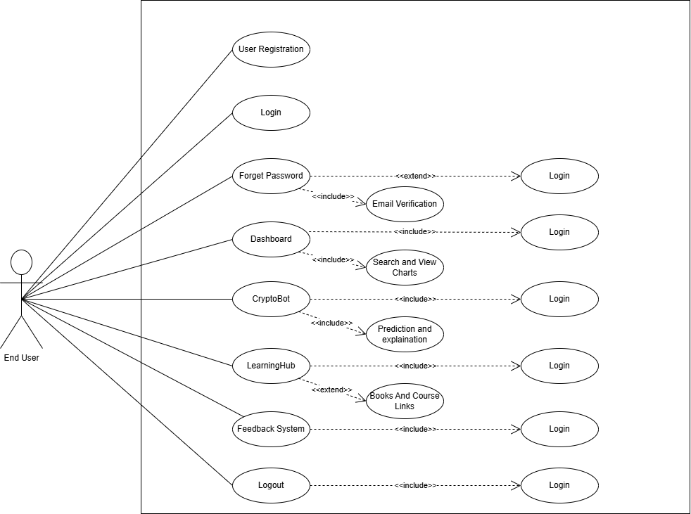

Figure 3 Admin Use Case Diagram
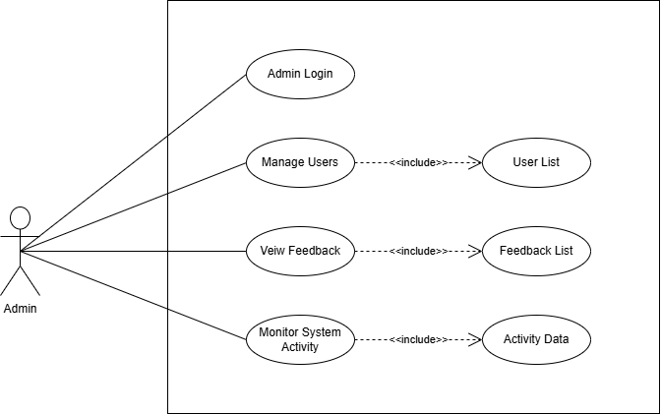
Figure 4 Marketing User Use Case Diagram
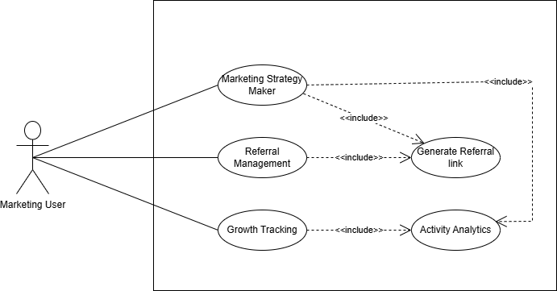

Storyboard
Figure 5 storyboard picture
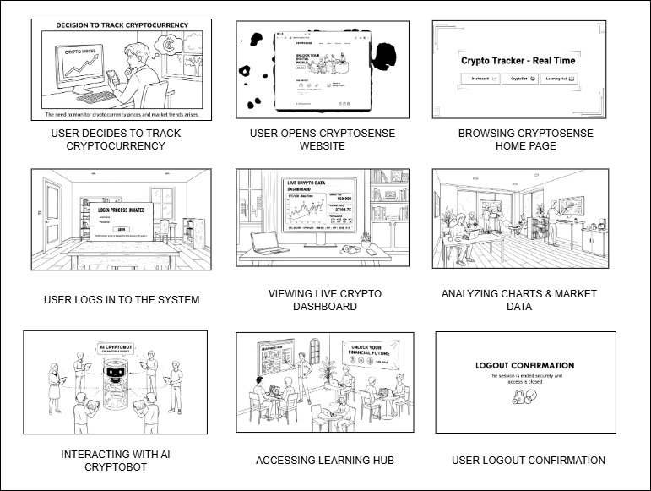

Summary
CryptoSence is a platform that combines login security, live crypto prices, Cryptobot support, Learning Hub, feedback system, admin management and marketing strategy features in one system. It uses Coingecko API for real time cryptocurrency data and Gemini API for chatbot responses and explanations. This system helps users to understand cryptocurrency in a simple way and also supports learning, planning and system management through a secure and user friendly platform.

Chapter No 4

Software Design Specification

System Design

Product Perspective:
The website name is CryptoSence and it is a client server architecture.
The CryptoSence website provide:
- Live crypto data
- Cryptobot for prediction and explanation
- User login/signup
- Crypto education support
- Feedback system
- Admin Management
- Marketing strategy
It is made using the MERN stack

Dependencies:
CryptoSence needs the following things to work:
- Coingecko API to get live crypto market data.
- Gemini API to generate prediction.
- React.js to make the website
- Node.js + Express for backend
- MongoDB to store user accounts
- Internet connection must required

Design Constraints:
- Performance Requirements: The system should display crypto data and chatbot response within few seconds.
- Usability Requirements: The system should be simple and easy to use for all users.
- Security Requirements: User password and login must be safe and secure. And API keys should be hidden

Design Considerations

Assumptions
Following are the assumptions:
- The system needs a stable internet connection
- User have a phone or computer with a web browser.

Dependencies
Following are the dependencies:
- Coingecko API for live crypto market data.
- Gemini API for generate answers.
- Internet connection.
- React.JS, Node.JS, Express.JS and MongoDB.

Limitations
Following are the limitations:
- Live crypto data uses free Coingecko API which have limited request.
- Cryptobot depend upon volume, RSI, and support/resistance for prediction.
- Both are not work without internet
- Free API may be slow or stop if to many people use it.

Risks
Following are the risks:
- If API of Coingecko and Gemini is fail due to some reason the live crypto data or Cryptobot response is also not work.
- Secondly if the more users call API from Coingecko so we need to buy paid version.

Requirements Traceability Matrix
Table 33 Requirement Traceability Matrix table
Requirement ID | Scope | Requirement Description | Design Specification
FR-1 | User Management | The user shall be able to register by entering username, email and password then account is created. | Component “User Authentication”
FR-2 | User Management | The user should be able to login by entering email and password then view dashboard. | Component “User Authentication”
FR-3 | User Management | The user shall be able to reset password by email. | Component “User Authentication”
FR-4 | Crypto Data | The user can view real time crypto prices, charts and market data. | Component “Dashboard”
FR-5 | AI Support | The user can ask questions and get crypto explanation from Cryptobot. | Component “Cryptobot”
FR-6 | Learning Support | The user can access learning content, books and YouTube links. | Component “LearningHub”
FR-7 | Feedback System | The user can submit feedback about the website. | Component “Feedback”
FR-8 | Admin Management | The admin can manage users and view feedback. | Component “Admin Dashboard”
FR-9 | Marketing Strategy | The marketing user can create strategy, use referral links and track growth. | Component “Marketing Dashboard”
FR-10 | User Management | The user can logout securely from the system. | Component “User Authentication”

Design Models
The CryptoSence is a three-tier architecture:
- Presentation Layer (React.js, HTML, CSS)
- Application Layer (Node.js/Express.js)
- Data Layer (MongoDB)
This is object oriented programming approach.

Design Class Diagram
Figure 6 Design Class Diagram
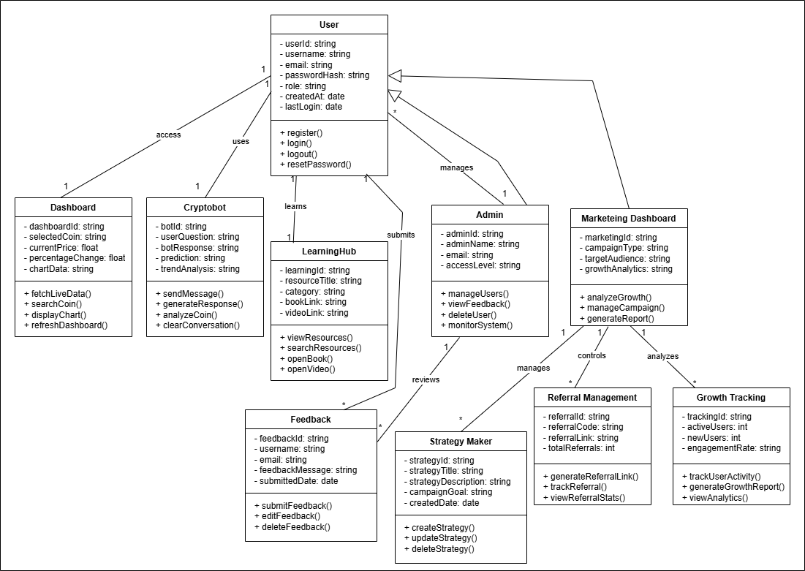

Sequence Diagram
- User Registration Sequence Diagram
Figure 7 User Registration Sequence Diagram
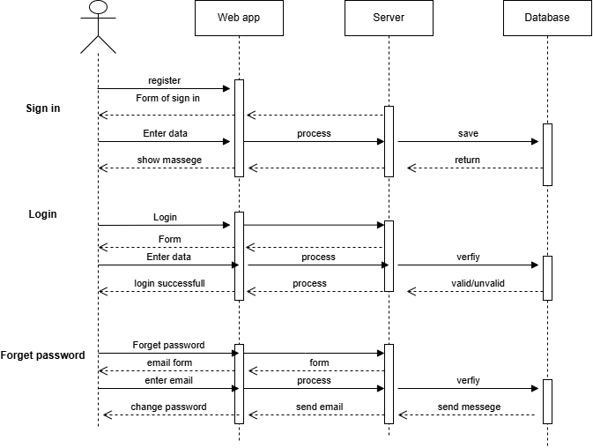
- User Home Page Sequence Diagram
Figure 8 Home page Sequence Diagram
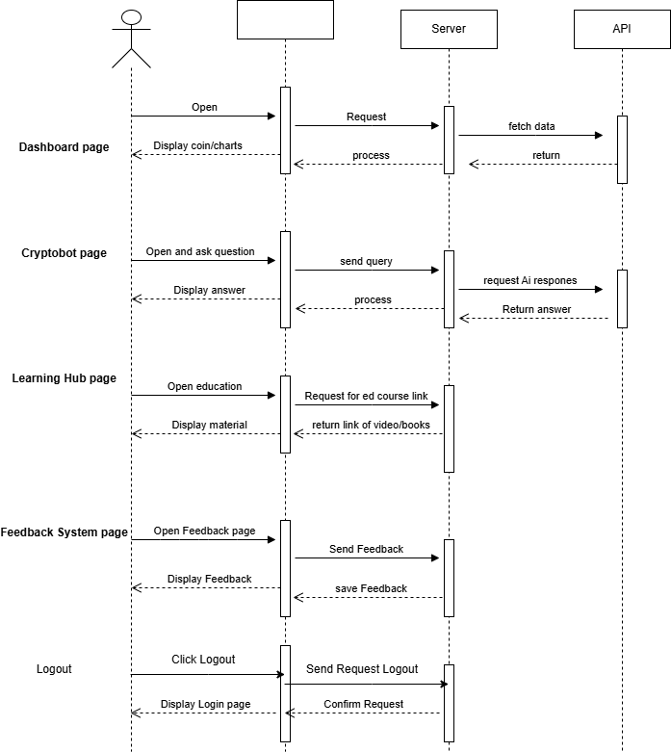

State Diagram
- User Registration State Diagram
Figure 9 User Registration State Diagram
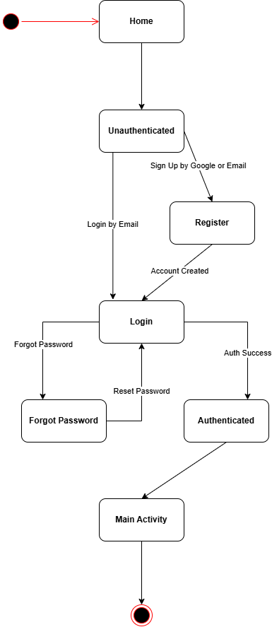

- User Dashboard State Diagram
Figure 10 Home Page State Diagram
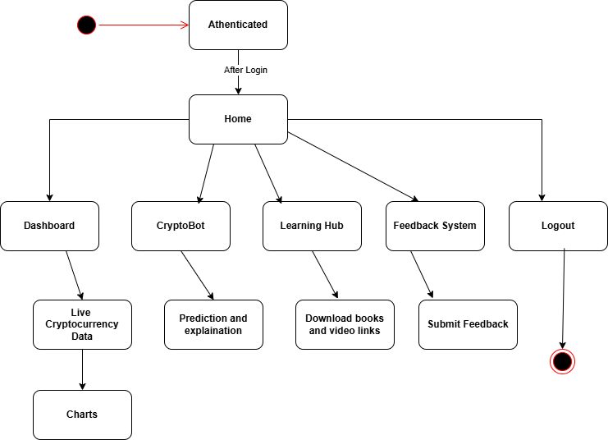

Architectural Design
The system uses a multi-tier design which means the work is divided into different parts. Each part has its own job. This makes the system easier to manage, faster to update, and better at handling changes.

Architectural Diagram
Figure 11 Architectural Diagram
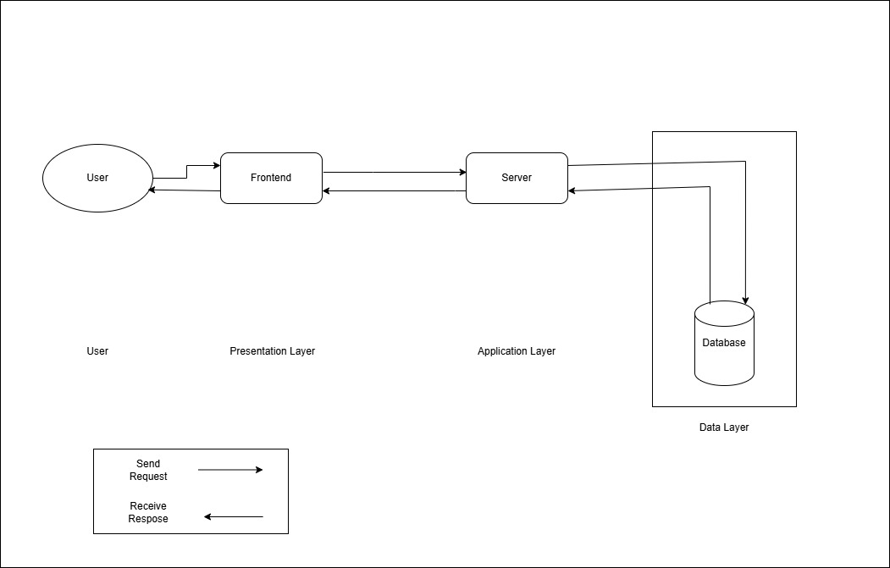

UML Component Diagram
Figure 12 UML Component Diagram
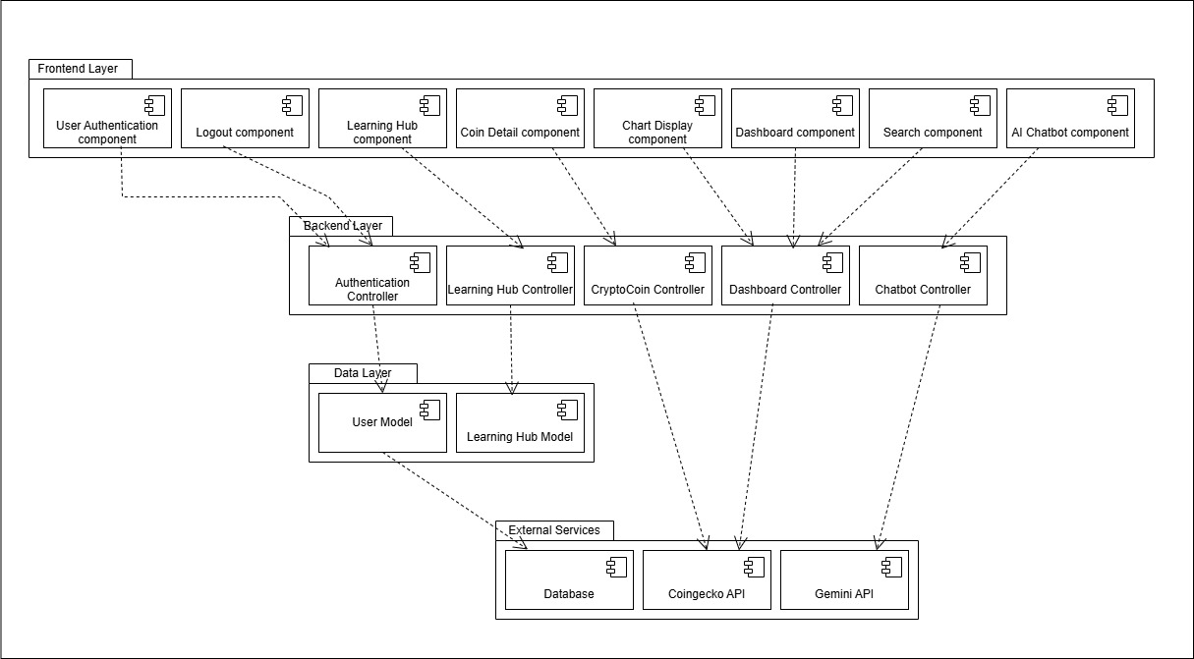

Data Design
The CryptoSence system converts user actions into organized data and stores it in MongoDB. Live cryptocurrency prices, charts, and market trends are not stored in the database because they are fetched directly from the Coingecko API. The system mainly stores user-related and system related data such as accounts, feedback, marketing strategies, and referral information.
The system uses different MongoDB collections to keep the data organized and easy to manage.

Database Collections Structure:
Users Collection
- Stores all user accounts.
- Supports normal login and Google login.
- Used for authentication and user personalization.
Fields:
- userId: Unique identifier
- username: Full name of the user
- email: User email address, must be unique
- passwordHash: Encrypted password
- role: User role such as user, admin, or marketing user
- createdAt: Account creation date
- lastLogin: Last login time
Data Relationship:
- One user has one account.
- No crypto data is stored in this collection.
Feedback Collection
- Stores feedback submitted by users.
- Helps improve system performance and user experience.
Fields:
- feedbackId: Unique feedback identifier
- name: User name
- email: User email
- message: Feedback text
- submittedAt: Date and time of submission
- status: Feedback status
Strategy Collection
- Stores marketing strategies created by marketing users.
- Used for planning and managing growth activities.
Fields:
- strategyId: Unique strategy identifier
- strategyTitle: Title of the strategy
- strategyDescription: Full strategy details
- targetAudience: Audience for the strategy
- createdAt: Date of creation
- status: Strategy status
Referral Collection
- Stores referral link information.
- Helps track user growth and referrals.
Fields:
- referralId: Unique referral identifier
- referralCode: Generated referral code
- referralLink: Referral URL
- createdBy: User who created the link
- createdAt: Date of generation
- totalClicks: Number of link clicks

Data Dictionary
Users Collection:
Table 34 Data Collection table
Terminology | Description
userId | String, primary key for user
username | String, user full name
email | String, unique email address
passwordHash | String, encrypted password
role | String, user role
createdAt | Date, when user registered
lastLogin | Date, last login time
feedbackId | String, primary key for feedback
message | String, feedback message
submittedAt | Date, feedback submission date
strategyId | String, primary key for strategy
strategyTitle | String, title of marketing strategy
strategyDescription | String, complete strategy details
targetAudience | String, strategy target users

User Interface Design
The user interface of CryptoSence is designed to display cryptocurrency information in a clean, simple, and user friendly way. The interface helps users easily access live crypto data, use the Cryptobot, explore learning resources, submit feedback, and manage marketing strategies.
User Experience
- The system is easy to use and works smoothly on both desktop and mobile devices.
- Users can quickly access live cryptocurrency prices, charts, and AI chatbot responses.
- Information is displayed in a simple and organized format for easy understanding.
- The system loads quickly and shows clear messages when errors occur.
- The interface is designed for both beginners and experienced crypto users.
How the User Uses the System?
1. Open the Website
- User opens the CryptoSence website using a browser on mobile or computer.
2. Login or Signup
- New users create an account using email and password.
- Existing users login using their credentials or Google login.
3. Go to Home Page
- After login, the user enters the Home Page.
- The Home Page contains:
  - Navigation bar
  - Quick access buttons for Dashboard, Cryptobot, Learning Hub, Feedback, and Marketing Strategy
4. Access Dashboard
- User opens the Dashboard page.
- The dashboard displays:
  - Live cryptocurrency prices
  - Percentage changes
  - Market charts
  - Search bar for cryptocurrencies
5. Search and View Crypto Details
- User searches for a cryptocurrency such as Bitcoin.
- The system displays market price, charts, and other coin details.
6. Use the Cryptobot
- User opens the Cryptobot page.
- User asks cryptocurrency related questions such as:
  - Give prediction
  - Explain market trends
- The Cryptobot returns AI generated responses and explanations.
7. Visit the Learning Hub
- Users open the Learning Hub page.
- Users can access educational materials, books, video tutorials, and learning links.
8. Submit Feedback
- Users open the Feedback page.
- Users enter feedback messages and submit suggestions about the system.
9. Use Marketing Strategy Features
- Marketing users open the Marketing Dashboard.
- Users can create strategies, manage referral links, and track growth activity.
10. Logout
- When finished, users logout securely from the system.

Screen Images

Home Page
Figure 13 Home Page design
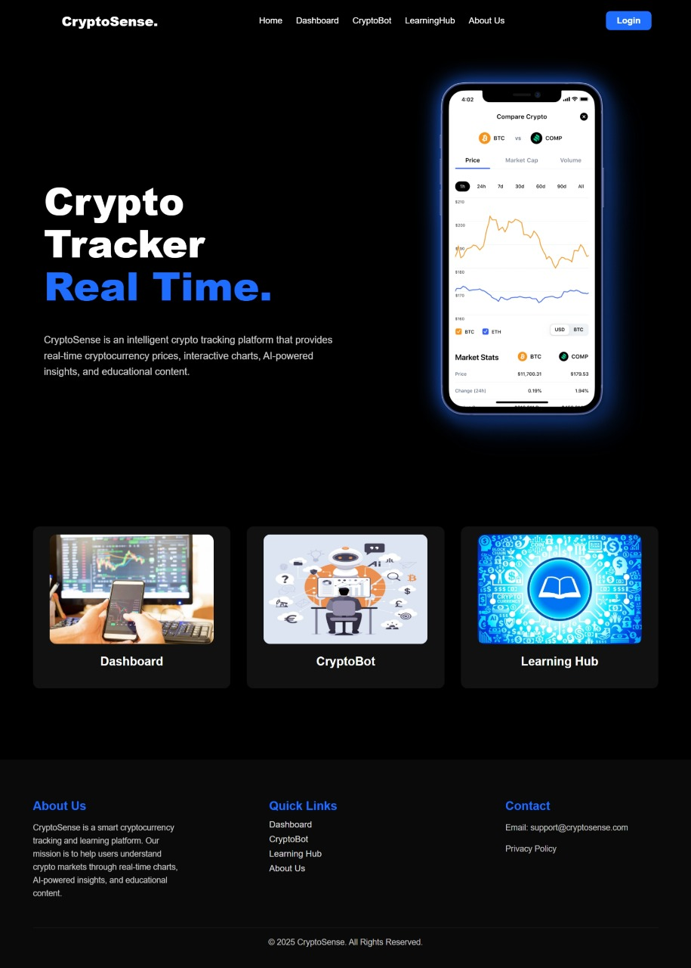

Login Page
Figure 14 Login Page Design
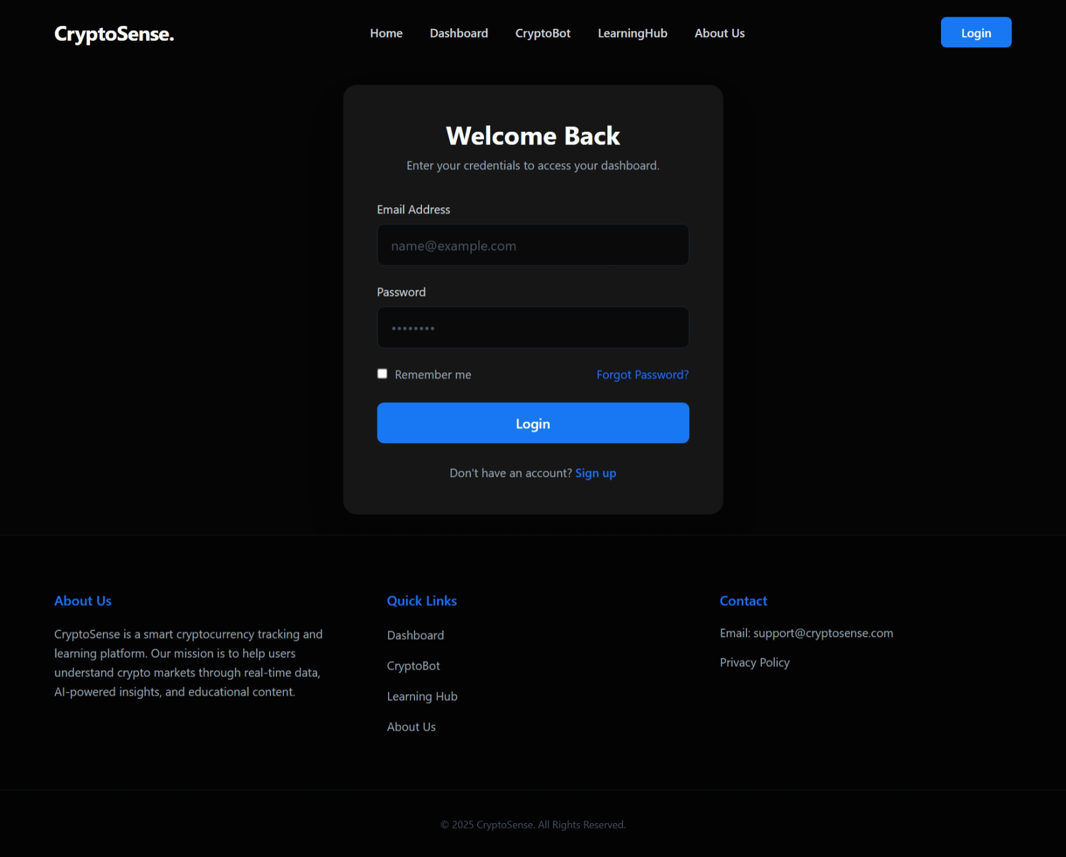

Dashboard Page
Figure 15 Dashboard Page Design
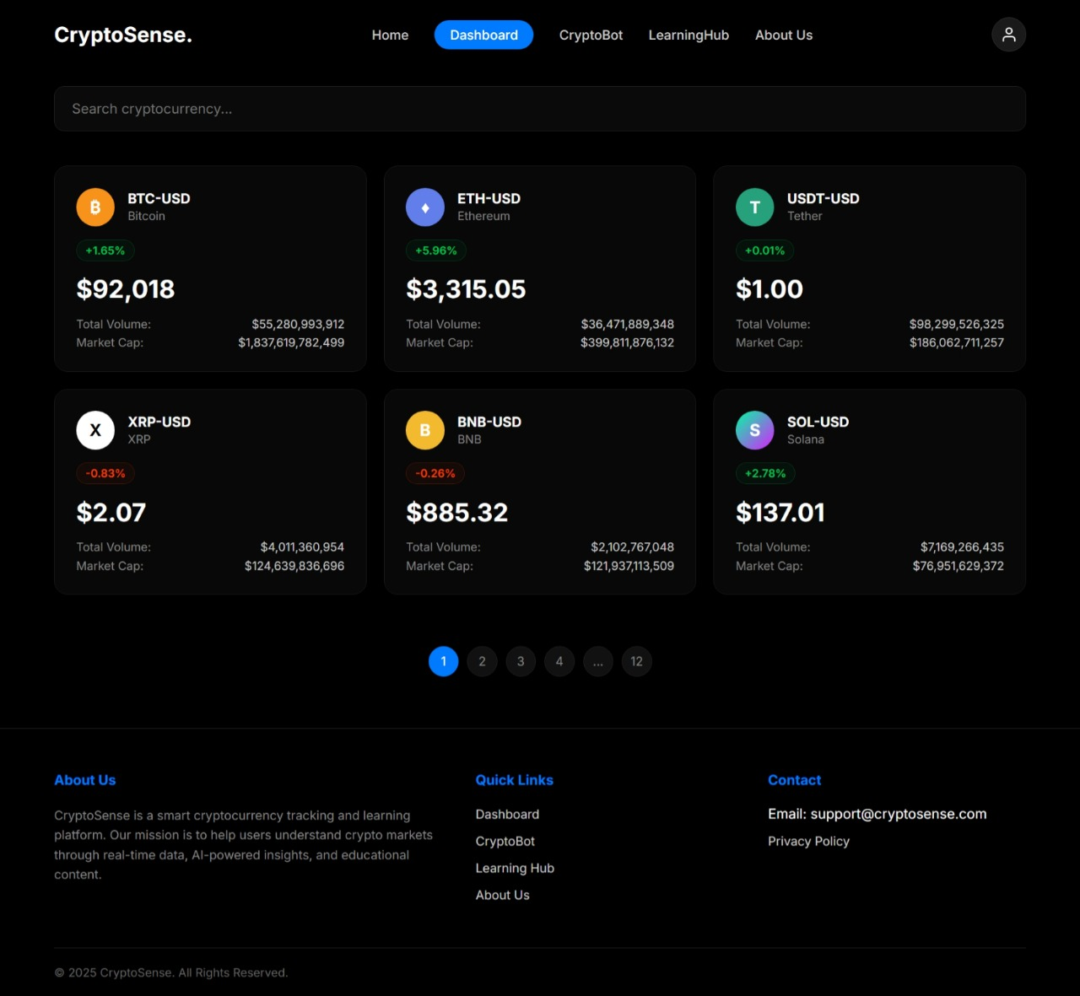

Cryptobot Page
Figure 16 Cryptobot Page Design
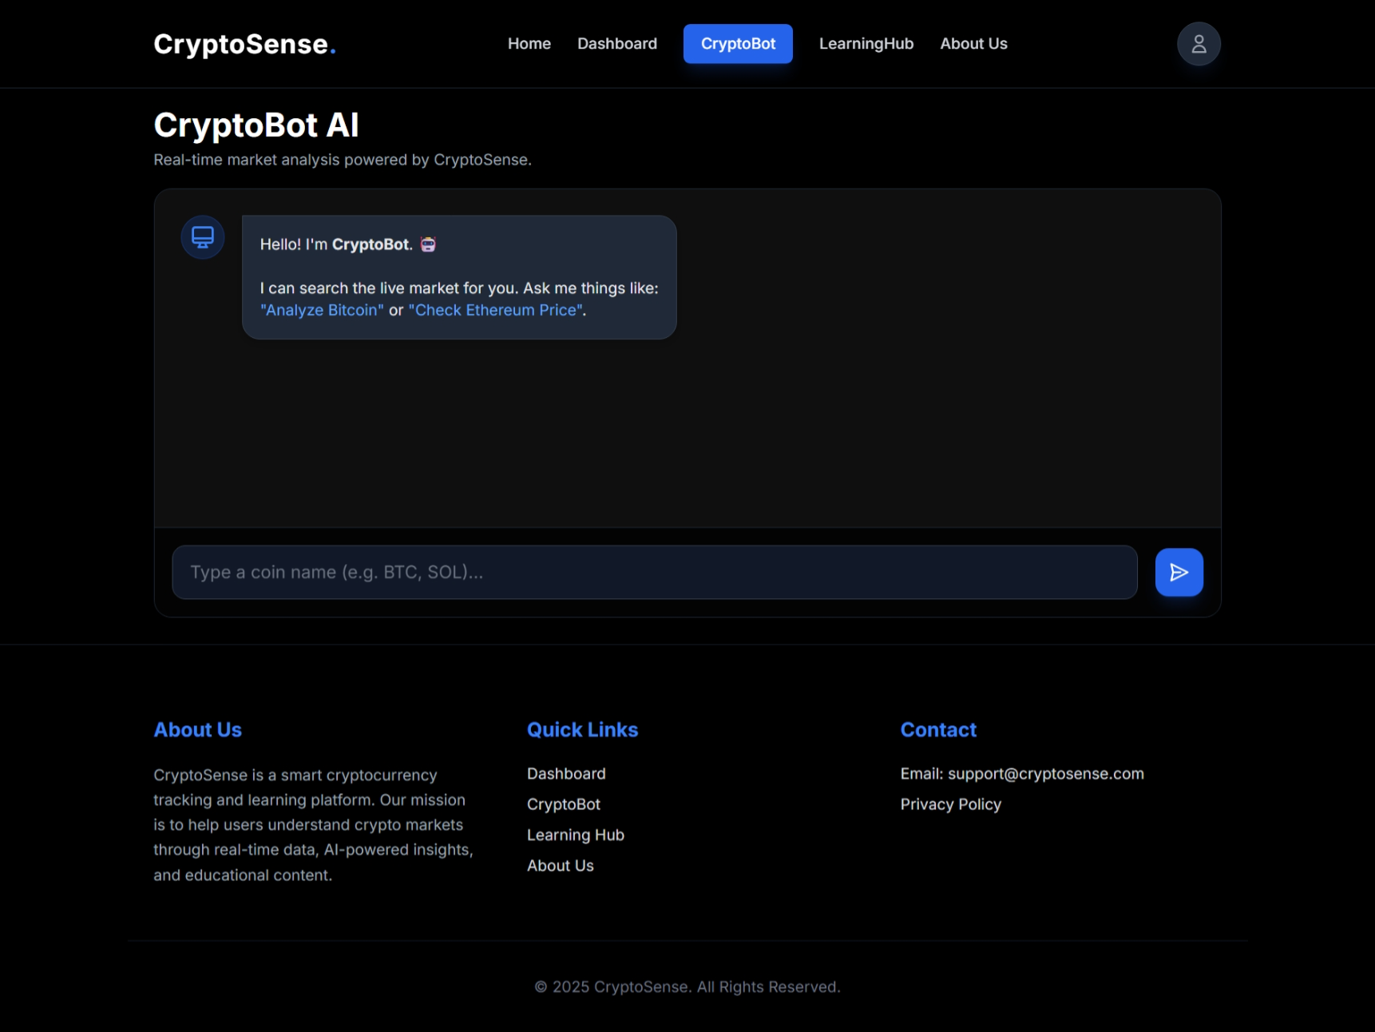

LearningHub Page
Figure 17 LearningHub Page


Screen objects and action
Screen Objects
- Nav bar: Home, Dashboard, Cryptobot, Learning Hub, Logout.
- Buttons: Login, Sign in, Google sign in/up, Search, Chat send
- Input Fields: Email, Password, Username, Search bar, Chat
- Boxes: Crypto price, chart, info.
- Charts: Chart for price
- Lists: Crypto list with price and percentage change.
- Icons: Search, profile, menu.
- Messages: Cryptobot messages.
- Footer: Links or credits.

User Actions
- Login / Sign in: User enters details and click login or sign in.
- Search Crypto: User search coins from bar.
- View Details: User clicks on a coin to see price, chart, and market data.
- Cryptobot: User use it for prediction and explanation about any coin.
- Nav bar: User clicks Dashboard, Cryptobot, Learning, etc.
- Logout: User clicks the logout to exit
- Google sign in/up: User signs in/up with google account.

Design Decisions
The system made several key architectural and technological choices to ensure the platform is secure, scalable, maintainable and a high quality user experience.
- Object Oriented Design (OOD):
We used the object oriented approach to build our system around real world entities such as User, Session, Chatmessage, and APIrequest. This code reusability and makes the system easier to use, test, and maintain in the future.
- MVC (Model-View-Controller) Architecture:
The system follows the Model-View-Controller pattern to separate concerns clearly:
  - Model interacts with MongoDB.
  - View is managed by React.js components
  - Controller contains the Express.js routes.
- Database Design with MongoDB:
We chose MongoDB because it is flexible and handles different types of data easily. It works well for user profiles and session data. It stores data in a simple way, so no complex joins are needed. This makes storing and retrieving data faster and easier.
- Rules & Cryptobot Logic:
  - A rule-based layer handle queries to show cryptocurrency data.
  - An AI layer using Gemini API provide prediction and trend explanation which based on technical indicators like volume, RSI, and support/resistance level.
- Technology Stack Selection:
  - Frontend: React.js with Chart.js.
  - Backend: Node.js and Express.js.
  - Database: MongoDB
  - Authentication: JWT (JSON Web Tokens) with bcrypt password hashing ensures secure user session and data protection.
  - External APIs: Coingecko API for real time cryptocurrency data and Gemini API for intelligent responses

Summary
This software design specification outlines the architectural, data, and behavioral designs for CryptoSence. The system shows live crypto data, Cryptobot, and educational content into one secure, fast, and user friendly platform.

Chapter No 5

Implementation

Implementation
This chapter explains the implementation details of the CryptoSence system. It includes the algorithms used in the project, external APIs and SDKs integrated into the system, and the Git repository used for version control and collaboration. The implementation is developed using React.js, Node.js, Express.js, MongoDB, Coingecko API, and Gemini API.

Algortihms
The following algorithms represent the main modules of the CryptoSence cryptocurrency analysis system. Each algorithm is written in pseudocode format with proper syntax and complexity analysis.
Table 35 Algorithm 1
Algorithm 1: User Login (email, password)
Input: email ← string, password ← string
Output: authenticated user session and dashboard access
1. if email == NULL or password == NULL then:
2. display ← "Please fill all fields"
3. return
4. end if
5. response ← SendToServer(email, password)
6. if response.status == "SUCCESS" then:
7. token ← response.data.JWT
8. role ← response.data.role
9. if role == "Admin" then:
10. NavigateTo(AdminDashboard)
11. else if role == "Marketing" then:
12. NavigateTo(MarketingDashboard)
13. else:
14. NavigateTo(UserDashboard)
15. end if
16. else:
17. display ← response.error_message
18. end if
Complexity: O(1) — Single database lookup and authentication process.
Table 36 Algorithm 2
Algorithm 2: FetchCryptoData (coinName)
Input: coinName ← string
Output: live cryptocurrency data displayed
1. if coinName == NULL then:
2. display ← "Enter coin name"
3. return
4. end if
5. apiResponse ← RequestCoingeckoAPI(coinName)
6. if apiResponse.status == "FAILED" then:
7. display ← "Live data unavailable"
8. return
9. end if
10. coinPrice ← apiResponse.price
11. percentageChange ← apiResponse.change
12. chartData ← apiResponse.chart
13. DisplayDashboard(
coinPrice,
percentageChange,
chartData
)
Complexity: O(1) — Single API request and response handling.
Table 37 Algorithm 3
Algorithm 3: CryptobotResponse (userQuestion)
Input: userQuestion ← string
Output: AI generated crypto explanation
1. if userQuestion == NULL then:
2. display ← "Enter question"
3. return
4. end if
5. response ← SendToGeminiAPI(userQuestion)
6. if response.status == "FAILED" then:
7. display ← "Cryptobot unavailable"
8. return
9. end if
10. botAnswer ← response.generatedText
11. DisplayChat(botAnswer)
Complexity: O(1) — Single API communication process.
Table 38 Algorithm 4
Algorithm 4: CreateMarketingStrategy (title, audience, goal)
Input: title ← string, audience ← string, goal ← string
Output: strategy created successfully
1. if title == NULL or audience == NULL or goal == NULL then:
2. display ← "Please fill all strategy fields"
3. return
4. end if
5. strategy ← CreateStrategy(
title,
audience,
goal
)
6. SaveToDatabase(strategy)
7. if save == FAILED then:
8. display ← "Strategy creation failed"
9. return
10. end if
11. display ← "Marketing strategy created successfully"
Complexity: O(1) — Single database insertion operation.
Table 39 Algorithm 5
Algorithm 5: SubmitFeedback (name, email, message)
Input: name ← string, email ← string, message ← string
Output: feedback stored successfully
1. if name == NULL or email == NULL or message == NULL then:
2. display ← "Please fill all fields"
3. return
4. end if
5. feedback ← CreateFeedback(
name,
email,
message
)
6. SaveToDatabase(feedback)
7. if save == FAILED then:
8. display ← "Feedback submission failed"
9. return
10. end if
11. display ← "Feedback submitted successfully"
Complexity: O(1) — Single database insertion operation.

External APIs/SDKs
The following table lists all third-party APIs, libraries, and SDKs used in the CryptoSence project.
Table 40 External APIs/SDKs
Name of API and Version | Description of API | Purpose of Usage | API Endpoint / Function
Coingecko API | Cryptocurrency market data API | Fetch live crypto prices and charts | /coins/markets
Gemini API | AI chatbot API | Generate crypto explanations and predictions | generateContent()
JSON Web Token (JWT) | Token based authentication | Secure login sessions | jwt.sign(), jwt.verify()
Mongoose | MongoDB object modeling | Database connection and queries | mongoose.connect(), Model.save()

Code Repository
Git is used to manage the CryptoSence project and track all changes in the code. All frontend files, backend files, APIs, database models, and project documents are stored in the Git repository. This helps team members work together easily and keeps the latest version of the project updated.
Git Repository Link: https://github.com/hamzanadeem4956-cmyk/CryptoSense

Metrices of the git repository
The following metrics are monitored to ensure effective use of the Git repository:
Commits
Tracks development progress and implementation frequency of project modules.
Branches
Separate branches are created for authentication, dashboard, Cryptobot, Learning Hub, feedback system, admin management, and marketing strategy modules.
Pull Requests
Pull requests are used before merging new features into the main branch to ensure code quality and collaboration.
Issues
Issues are created for bug tracking, task management, and feature enhancement.
Contributors
All team members contribute through commits, pushes, and branch management.
Code Reviews
Each feature branch is reviewed before merging into the main repository.

Summary
In this chapter, we explained the implementation of the CryptoSence system. We discussed the main algorithms used for login, live crypto data, Cryptobot, feedback, and marketing strategy features. We also explained the APIs, tools, and Git repository used in the project. All main modules of the system have been implemented successfully.

Chapter No 6

Testing and Evaluation

Introduction
Testing is performed to make sure the CryptoSence system works correctly and smoothly. Different types of testing are used to check login, dashboard, Cryptobot, feedback system, and marketing strategy features. The testing process helps find errors and improve system performance and reliability.

Unit Testing (UT)
Unit testing is used to test individual modules and functions of the system.
Table 41 UT-1
Test Case ID | UT-1
Requirement ID | FR-1, FR-2
Title | Login screen renders correctly
Description | Verify that email field, password field, and login button are visible
Precondition | User opens login page
Test Steps | 1. Open website  2. Navigate to login page  3. Observe login screen
Input | User opens login page
Expected Result | All fields and buttons are visible and clickable
Actual Result | All elements displayed correctly
Status | Pass
Table 42 UT-2
Test Case ID | UT-2
Requirement ID | FR-4
Title | Dashboard screen loads correctly
Description | Verify that crypto prices, charts, and search bar are displayed
Precondition | User logged in successfully
Test Steps | 1. Login to system  2. Open dashboard
Input | User dashboard request
Expected Result | Dashboard loads live crypto data correctly
Actual Result | Dashboard displayed successfully
Status | Pass
Table 43 UT-3
Test Case ID | UT-3
Requirement ID | FR-5
Title | Cryptobot screen renders correctly
Description | Verify that chatbot input field and send button are visible
Precondition | User logged in
Test Steps | 1. Open Cryptobot page  2. Observe chatbot interface
Input | User opens Cryptobot page
Expected Result | Chat interface displayed correctly
Actual Result | All chatbot elements rendered correctly
Status | Pass
Table 44 UT-4
Test Case ID | UT-4
Requirement ID | FR-6
Title | Learning Hub loads correctly
Description | Verify that educational resources and links are displayed
Precondition | User logged in
Test Steps | 1. Open Learning Hub page  2. Check resources
Input | User opens Learning Hub
Expected Result | Books, videos, and links displayed
Actual Result | Learning content displayed correctly
Status | Pass
Table 45 UT-5
Test Case ID | UT-5
Requirement ID | FR-7
Title | Feedback screen renders correctly
Description | Verify that feedback form fields and submit button are visible
Precondition | User logged in
Test Steps | 1. Open feedback page  2. Observe feedback form
Input | User opens feedback page
Expected Result | All feedback fields visible
Actual Result | Feedback form displayed correctly
Status | Pass

Functional Testing (FT)
Functional testing checks that all system features work correctly from the user's point of view.
Table 46 FT-1
Test Case ID | FT-1
Requirement ID | FR-1, FR-2
Title | User login authentication
Description | Verify that users can login with valid credentials
Precondition | User account exists in database
Test Steps | 1. Enter email and password  2. Click login
Input | Valid email and password
Expected Result | User redirected to dashboard
Actual Result | Login successful
Status | Pass
Table 47 FT-2
Test Case ID | FT-2
Requirement ID | FR-4
Title | Live crypto data display
Description | Verify that dashboard displays real-time crypto prices
Precondition | Internet connection available
Test Steps | 1. Open dashboard  2. Search cryptocurrency
Input | Bitcoin
Expected Result | Live crypto data displayed
Actual Result | Live prices loaded correctly
Status | Pass
Table 48 FT-3
Test Case ID | FT-3
Requirement ID | FR-5
Title | AI chatbot response
Description | Verify that Cryptobot generates AI responses
Precondition | Gemini API configured
Test Steps | 1. Open Cryptobot  2. Ask question
Input | “Explain Ethereum”
Expected Result | AI response generated
Actual Result | Correct response displayed
Status | Pass
Table 49 FT-4
Test Case ID | FT-4
Requirement ID | FR-7
Title | Submit feedback
Description | Verify that user can submit feedback successfully
Precondition | User logged in
Test Steps | 1. Fill feedback form  2. Click submit
Input | Name, email, feedback message
Expected Result | Feedback stored in database
Actual Result | Feedback submitted successfully
Status | Pass
Table 50 FT-5
Test Case ID | FT-5
Requirement ID | FR-9
Title | Marketing strategy creation
Description | Verify that marketing user can create strategy
Precondition | Marketing user logged in
Test Steps | 1. Open strategy page  2. Enter strategy details  3. Save strategy
Input | Strategy title and goal
Expected Result | Strategy saved successfully
Actual Result | Strategy created correctly
Status | Pass

Integration Testing (IT)
Integration testing checks that different modules and APIs work together correctly.
Table 51 IT-1
Test Case ID | IT-1
Requirement ID | FR-4
Title | Dashboard with Coingecko API
Description | Verify that dashboard receives live data from Coingecko API
Precondition | API connected successfully
Test Steps | 1. Open dashboard  2. Refresh data
Input | Crypto data request
Expected Result | Live data loaded from API
Actual Result | API integration working correctly
Status | Pass
Table 52 IT-2
Test Case ID | IT-2
Requirement ID | FR-5
Title | Cryptobot with Gemini API
Description | Verify that Cryptobot receives AI responses from Gemini API
Precondition | Gemini API connected
Test Steps | Ask question in chatbot
Input | User crypto question
Expected Result | AI response returned successfully
Actual Result | API integration successful
Status | Pass

Performance Testing (PT)
Performance testing measures how fast the system loads and responds.
Table 53 PT
Screen | Load Time | Status
Login Page | 280 ms | Pass
Dashboard Page | 320 ms | Pass
Cryptobot Page | 300 ms | Pass
Learning Hub Page | 260 ms | Pass
Feedback Page | 250 ms | Pass
Admin Dashboard | 310 ms | Pass
Marketing Dashboard | 315 ms | Pass

Summary
All features of CryptoSence were tested successfully. Unit testing confirmed that all screens load correctly. Functional testing confirmed that login, dashboard, Cryptobot, feedback system, and marketing strategy features work properly. Integration testing confirmed successful communication with Coingecko API and Gemini API. Performance testing showed that all pages load quickly and smoothly.

Chapter No 7

System Conversion

Introduction
This chapter explains how CryptoSence was converted from a development project into a fully working deployed system. It covers the conversion method, deployment process, data conversion, user training, post deployment testing, and challenges faced during deployment. The system includes live cryptocurrency data using Coingecko API, AI chatbot support using Gemini API, secure authentication using JWT, and a responsive frontend using React.js.

Conversion Method
CryptoSence used the phased conversion method. The system was developed and deployed step by step. Each phase was tested completely before moving to the next phase.
Phase 1 – Completed
Frontend user interface developed using React.js including login, dashboard, Cryptobot, Learning Hub, feedback system, admin dashboard, and marketing strategy pages.
Phase 2 – Completed
Backend connected using Node.js and Express.js. MongoDB database fully integrated with authentication and system modules.
Phase 3 – Completed
Coingecko API integrated for live cryptocurrency prices, charts, and market trends.
Phase 4 – Completed
Gemini API integrated for AI chatbot responses and crypto explanations.
Phase 5 – Completed
Admin management, feedback system, and marketing strategy modules deployed successfully.

Deployment
CryptoSence was deployed in two stages development deployment and production deployment.
Development Deployment
Development deployment was used during testing and development of the project.
Step 1: Install Node.js and MongoDB on the system.
Step 2: Clone the project repository:
git clone https://github.com/your-project-link
Step 3: Open project folder:
cd CryptoSence
Step 4: Install project dependencies:
npm install
Step 5: Start frontend React application:
npm start
Step 6: Start backend server:
node server.js
Step 7: Connect MongoDB database and environment variables.
Step 8: Test all modules in development environment.
Development deployment was used throughout the testing phase before moving to production.

Production Deployment
Production deployment was done after all modules were tested successfully.
Step 1: Build React frontend:
npm run build
Step 2: Configure production environment variables.
Step 3: Upload frontend and backend files to hosting server.
Step 4: Connect MongoDB production database.
Step 5: Configure Coingecko API and Gemini API keys.
Step 6: Deploy backend server using Node.js hosting.
Step 7: Test frontend and backend communication.
Step 8: Verify dashboard, Cryptobot, Learning Hub, feedback, and marketing strategy modules.
The production deployment worked successfully without major errors.

Data Conversion
CryptoSence uses MongoDB for storing system data.
MongoDB Collections
- users
- feedback
- strategies
- referrals
- activityLogs
Data Conversion Process
- MongoDB collections were created.
- Default admin account was added manually.
- User accounts are created through registration.
- Feedback and strategy data are stored automatically.
- Database backup was created before deployment.
- All data was validated before the system went live.

Training
End User – How to Use CryptoSence
- Register account using email and password.
- Login to access dashboard.
- View live cryptocurrency prices and charts.
- Use Cryptobot for crypto questions and explanations.
- Open Learning Hub resources.
- Submit feedback through feedback form.
- Logout securely after usage.
Admin – How to Use CryptoSence
- Login using admin credentials.
- Open admin dashboard.
- Manage users and feedback records.
- Monitor system activity and reports.
- Review feedback submissions.
Marketing User – How to Use CryptoSence
- Login using marketing account.
- Open marketing dashboard.
- Create marketing strategies.
- Generate referral links.
- Track growth and user activity reports.

Post Deployment Testing
Table 54 Post Deployment Testing Table
Test ID | What Was Checked | Result
PDT-01 | Website opens correctly | Pass
PDT-02 | Login system works correctly | Pass
PDT-03 | Dashboard displays live crypto data | Pass
PDT-04 | Coingecko API integration works | Pass
PDT-05 | Cryptobot generates AI responses | Pass
PDT-06 | Gemini API integration works | Pass
PDT-07 | Feedback system stores data correctly | Pass
PDT-08 | Marketing strategy module works correctly | Pass
PDT-09 | MongoDB database saves and retrieves data | Pass
PDT-10 | Admin dashboard works correctly | Pass
PDT-11 | GitHub repository updated successfully | Pass

Challenges

Table 55 Challenges Table
Challenge | Solution
Coingecko API request limits | Optimized API requests and refresh intervals
Gemini API response delays | Improved backend request handling
MongoDB connection errors | Updated database configuration
JWT authentication issues | Fixed token verification middleware
Deployment environment variable issues | Added API keys to .env configuration
Slow dashboard loading | Optimized frontend rendering and API calls

Summary
CryptoSence has been fully developed and deployed successfully. The system now includes live cryptocurrency tracking, AI chatbot support, Learning Hub resources, feedback management, admin control, and marketing strategy features. MongoDB, Coingecko API, and Gemini API were integrated successfully. All modules worked correctly during post deployment testing and the system is ready for real users.

Chapter No 8

Conclusion

Introduction
This chapter presents the final conclusion of the CryptoSence project. It explains the evaluation of project objectives, requirement traceability, conclusion of the system, and future improvements that can be added later. The project was developed to provide a simple and user friendly cryptocurrency analysis platform with live crypto data, AI chatbot support, learning resources, feedback management, admin control, and marketing strategy features.

Evaluation
Table 56 Evaluation Table
Objectives | Status
Provide live cryptocurrency prices and charts | Completed
Develop AI based Cryptobot support | Completed
Implement user authentication system | Completed
Create Learning Hub resources | Completed
Implement feedback system | Completed
Develop admin management module | Completed
Develop marketing strategy module | Completed
Integrate Coingecko API successfully | Completed
Integrate Gemini API successfully | Completed
Create responsive and user friendly interface | Completed

Traceability Matrix
The following table shows the relationship between requirements, design modules, implementation files, and testing modules
Table 57 Traceability Matrix Test
Requirement ID | Requirement Description | Design Specification | Code / Module | Test ID
FR-1 | User Registration | Authentication Module | register.jsx | UT-1
FR-2 | User Login | Authentication Module | login.jsx | FT-1
FR-3 | Forget Password | Authentication Module | forgotpassword.jsx | UT-1
FR-4 | Live Crypto Dashboard | Dashboard Module | dashboard.jsx | FT-2
FR-5 | Cryptobot Support | Cryptobot Module | cryptobot.jsx | FT-3
FR-6 | Learning Hub | LearningHub Module | learninghub.jsx | UT-4
FR-7 | Feedback System | Feedback Module | feedback.jsx | FT-4
FR-8 | Admin Management | Admin Dashboard | admin.jsx | UT-5
FR-9 | Marketing Strategy | Marketing Module | marketing.jsx | FT-5
FR-10 | Logout System | Authentication Module | navbar.jsx | FT-1

Conclusion
CryptoSence was successfully developed as a cryptocurrency analysis and learning platform. The system provides live cryptocurrency prices, charts, AI chatbot responses, educational resources, feedback management, admin control, and marketing strategy features in one platform.
The integration of Coingecko API and Gemini API improved the functionality of the system by providing real time market data and AI based crypto explanations. React.js, Node.js, Express.js, and MongoDB helped create a secure, responsive, and scalable web application.
All project objectives and functional requirements were implemented successfully. Testing results confirmed that the system works correctly and performs efficiently.

Future Work
The following improvements can be added in future versions of CryptoSence:
- Add real cryptocurrency trading support
- Develop Android and iOS mobile applications
- Add portfolio management system
- Add advanced AI based trading prediction
- Add dark mode and theme customization
- Add multi language support
- Add advanced technical analysis indicators
- Add notification and alert system for crypto prices
- Improve marketing analytics and reporting features

References

References

World Wide Web
- Meta Platforms Inc., "React Documentation,". Available: https://react.dev/.
- System Design Specification (SDS) "YouTube lecture used to understand Software / System Design Specification". Available: https://www.youtube.com/watch?v=hOH7eD9NJgY .
- Class Diagram (UML), "YouTube tutorial used to learn UML Class Diagrams". Available: https://www.youtube.com/watch?v=6XrL5jXmTwM .
- Component Diagram, "YouTube tutorial used to understand Component Diagrams". Available: https://youtu.be/CW9Ts2qLfEI?si=QXdUxthCEo-fcigr .
- Sequence Diagram, "YouTube tutorial used to learn Sequence Diagrams using draw.io". Available: https://www.youtube.com/watch?v=rsTWufuP328 .
- OpenJS Foundation, "Node.js Documentation,". Available: https://nodejs.org/en/docs/.
- MongoDB Inc., "MongoDB Manual,". Available: https://www.mongodb.com/docs/manual/.
- The guide for using Mongoose with a database., "Mongoose Documentation," Available: https://mongoosejs.com/docs/.
- Coingecko. “Coingecko API Documentation.”
Internet: https://www.coingecko.com/en/api.
- Gemini. “Gemini API Documentation.” Internet: https://platform.gemini.com/docs.
- Auth0, "Introduction to JSON Web Tokens,". Available: https://jwt.io/introduction.
- Draw.io User Manual for UML Diagrams. Available: https://www.drawio.com/.

